Zombie Maze

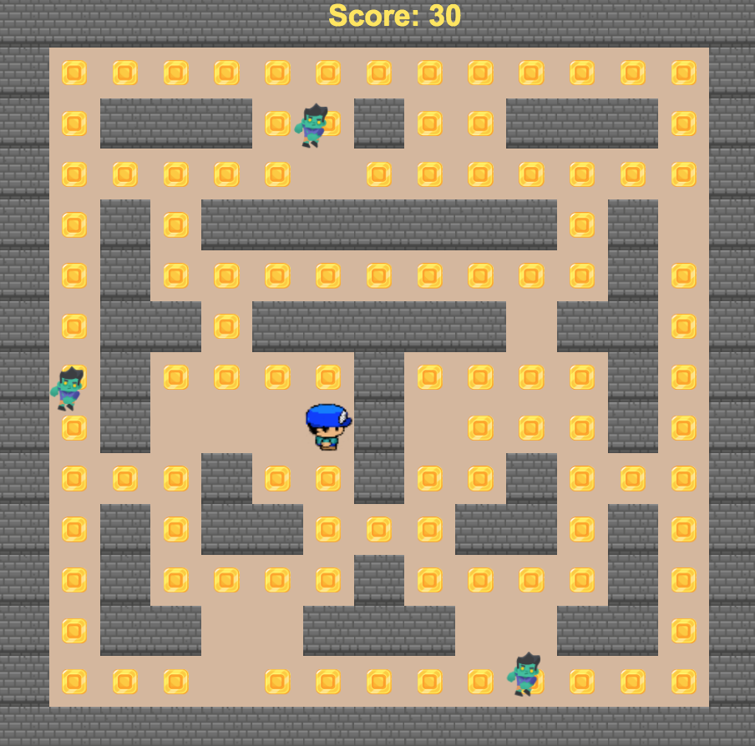
Figure 1: Zombie Maze

- Overall Vision

Summary
The game Zombie Maze consists of a character, Waldo, who has to walk through a maze and collect as many coins as he can before a zombie catches him. If a zombie collides with him, the game is over. To win the game, Waldo has to collect all the coins on the maze.

Genre
This game could be described as a survival game, where the character has to avoid and survive the enemies to win. It could also be considered a maze/arcade game, where objects in an area have to be collected.

Target Audiences | Target Platforms
- kids ages 5-14  - Young adults  - Adults | - Windows PC  - Mac  - Linux

- Mechanics

Character
The main character is a blue man. For the purpose of the game he is called “Waldo.” His main objective is to collect all the coins in a maze, while avoiding contact with the enemies (zombies). To win the game, Waldo has to collect all the coins before a zombie touches him. He moves in the directions north, south, east, and west. For the character to move, the player has to use the keyboard arrows.

Figure 2: Main character- Waldo

Abilities/ Items
The ninja has the ability to walk in the directions NSEW, with keyboard arrows. He has the ability to collect coins by just being in contact with them. As soon as he collects them, the coins fade away and are added to his score. The coins are static and are initially present on the maze.

Figure 3: Collectable coins
Enemies
The only enemy on this game is a Zombie. He has the ability to move in the same directions (north, south, east, west) as Waldo. However, one of the zombies is programmed to move randomly through the maze, while not touching any of the walls. He cannot be destroyed by Waldo. But, he can end the game by colliding with him.

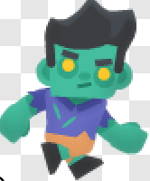
Figure 4: Zombie

Obstacles
Since this is considered a Maze game, the only obstacles on the terrain are the walls. If the main character or the enemies touch the walls, the movement stops. Therefore, they have to find a new direction to move to.

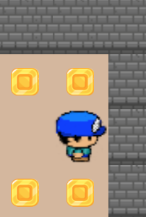
Figure 5: walls

- Dynamics
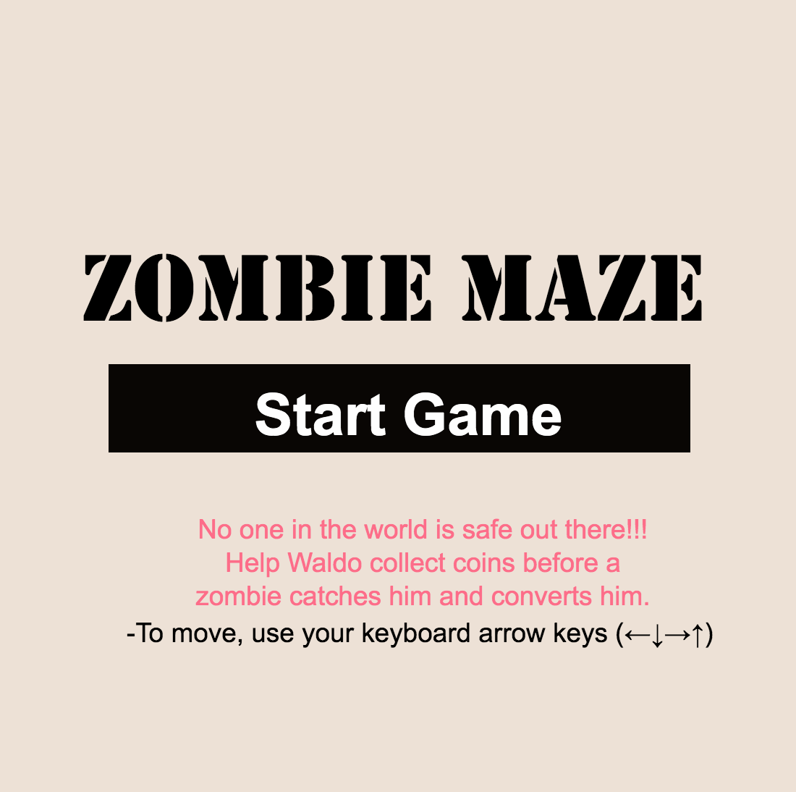
Figure 6: Instruction Page

User Interface and Interaction
The equipment required to play the game is a computer (desktop or laptop). The game can be controlled initially with the mouse. Once the “start game” button is pressed, the game is controlled with the keyboard arrows. These arrows will allow the moment of the player in four directions: north, south, east, west (up, down, right, left). To restart the game the user can press (command +R) on the keyboard and the game will be redirected to the main screen. Instead of adding a game over page, the texts "You Win!" and "You lose" were included on the main screen after the character collides/completes the level.
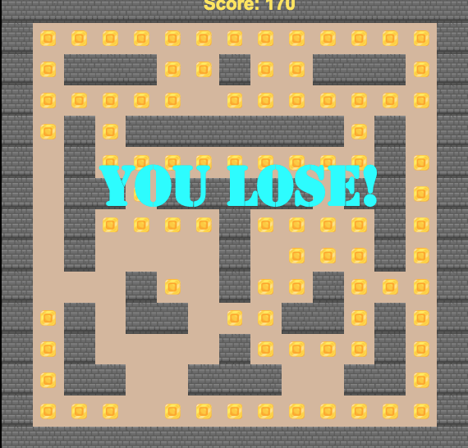
Figure 7: You lose text

Proficiency
The game can be considered low to medium difficulty. The only ability the player needs to have is coordination pressing the keys. To become fully proficient the use of the four keys and speed is necessary.

Gameplay Data
The only data on the game is the SCORE. This is displayed at the top of the screen in yellow. This data changes as the player collects more coins throughout the maze.

- Aesthetics

Overall, the look of the game Zombie Maze is very clean and simple looking, could even be described as minimalistic. The colors used on the main screen are black, white, and red. Once the game start, the main colors are grey, yellow, blue and green. With the use of contrasting and simple colors like yellow and grey it is easy for the user to distinguish the walls from the maze from the coins.

Game art
The game uses both pixel art, for the characters and coins, as well as line art, for the walls. Colors are varied but very neutral.

Sound
The only sound used for this game was the song ““Volvion-chase-8,” which was acquired from a royalty- free website (freesound.com). The song begins at the start of the layout and will restart every time the game is restarted.

Figure 8: Sound elements
Plot
The backstory of this game is the invasion of zombies to the world and the need for humans to escape them. In this game, the player is collecting items while escaping the zombies.

Emotional State
This game is meant to provoke anxiety on the users. The player has to escape while at the same time focus on collecting coins.

- Credits

All assets used for the creation of this game were collected from royalty free websites, for public domain
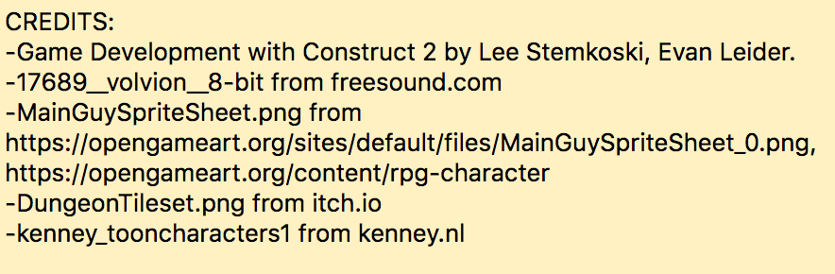
Figure 9: Credits at the end of event sheet
- Artwork:
  - MainGuySpriteSheet.png from https://opengameart.org/sites/default/files/MainGuySpriteSheet_0.png, https://opengameart.org/content/rpg-character
  - DungeonTileset.png from itch.io
  - Kenney_tooncharacters1 from kenney.nl

- Sound:
  - 17689__volvion__8-bit from https://freesound.org/people/Volvion/sounds/315717/

For this project, many of the assets utilized were obtained from royalty free websites were the name of the authors was unknown or anonymous. Nonetheless, thank you so much to the creators for their generosity and hard work when creating all these assets and quality looking art. Additionally, thanks for making these resources free to students and the general public.
A special thank you to the authors of the book “Game Development with Construct 2,” Lee Stemkoski and Evan Leider. The use was a fantastic resource to use when creating the game and learning about sprite behaviors like bullet, timer, and fade. I would highly recommend this book to anyone who has interest in learning more about Construct.

Reflection and Personal experience
This game was a very different style of game than the ones I had created before. Since I had just previously done a platform game called Fruit Ninja, I decided I wanted to do something like Pac-man. I would personally call this style of game maze. This game was less time consuming than the one I had previously done, as well, as it had less bugs I had to clean. The only main problem I encountered was using spawn (making an item from one place, appear on another). I wanted to create a treasure that the character could occasionally see during his walk on the maze to obtain more points. However, after many attempts I decided to just stick with the basic collision of coins.
One thing that I found more interesting on this type of game is the use of more art and creativity. The tool tile background as well as tile map were tools I had never used, so I decided to invest some more time watching tutorials on how to use these objects. Other than that, the programming behind the behaviors was very simple with the help of some math and logic.
For my next game experience, I would like to further improve this game and create new levels, enemies and obstacles. I believe this type of game is very easy to understand and people from every age can play it. Hopefully I can also make this game work on mobile devices to show it to my friends and family.

